Floor in a Binary Search Tree.
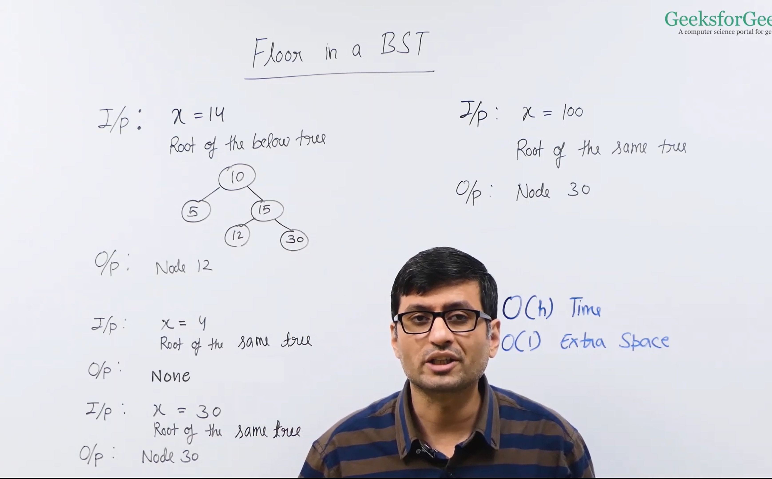
By using the traversal, we can do in the O(h).
For the recursive we need O(h) extra space for us.


